STEP UP CONVERTOR

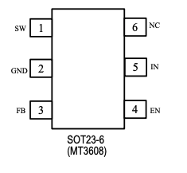

**SW (Pin 1 - Power Switch Output):**

* This pin is connected to the drain of the internal MOSFET switch.
* You need to connect the power inductor and output rectifier (diode) to this pin.
* The voltage at this pin can swing between GND and up to 28V.
* It's responsible for controlling the switching of the inductor current in the boost converter circuit.

**GND (Pin 2 - Ground Pin):**

* This is the ground connection for the converter.
* It serves as the return path for the input and output currents.
* It should be connected to the common ground of your circuit.

**FB (Pin 3 - Feedback Input):**

* This pin is used to regulate the output voltage.
* The feedback voltage is set to 0.6V. To adjust the output voltage, a resistor divider network is connected to this pin.
* The converter adjusts its output based on the voltage fed back to this pin.

**EN (Pin 4 - Regulator Enable/On-Off Control Input):**

* This pin is used to turn the converter on or off.
* When the voltage on this pin is high, the converter is enabled (on). When it is low, the converter is disabled (off).
* If this pin is not used, it should be connected to the input supply voltage (IN) for automatic startup.

**IN (Pin 5 - Input Supply Pin):**

* This is where the input supply voltage is connected to power the converter.
* It must be bypassed with a local capacitor to stabilize the input voltage and prevent fluctuations.

**NC (Pin 6 - No Connection):**

* This pin is not internally connected to anything, so it doesn't need to be connected in your circuit.
* It's often left for mechanical support or reserved for future use.

STEP DOWN CONVERTOR

